
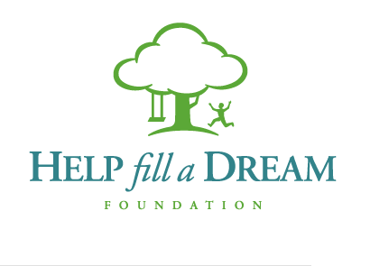

Your First and Last Name: ______________________________________
Total Amount Collected and Delivered: $___________________________ Proceeds benefit Help Fill A Dream Foundation
- Please PRINT all information. To receive a tax receipt, all contact information, including postal code must be filled out.
- Collect all pledges and donations in advance. All pledge money must accompany form.
- Please mail or drop off all cheques or cash to: Seaside Magazine’s “Taking It To The Street”, Unit D – 4085 Quadra St,
Victoria, BC V8X 1K5 or bring to the event on June 11, 2016
- Please make cheques payable to: Help Fill A Dream Foundation.
- TAX RECEIPTS ARE ISSUED FOR PLEDGES OF $20.00 OR MORE.
 | Title, First Name, Last Name | Address/City/  Postal Code | Phone/  Email | Credit Card No. | Expiry Date | Security Code | $$ Amt | Cash, Credit, Cheque | Request Receipt
 | Mr. Joe Sample | 111 Normal St  Anytown, V5V 5V5 | (123) 456-7890  jsample@fake.ca | 1234 5678 9012 3456 | 11/12 | 023 | $50 | CREDIT | yes
1
2
3
4

 | Title, First Name, Last Name | Address/City/  Postal Code | Phone/  Email | Credit Card No. | Expiry Date | Security Code | $$ Amt | Cash, Credit, Cheque | Request Receipt
5
6
7
8
9
10
11
12
13
14

